Choosing a Research Topic

Literature Review

* Semantic Segmentation Papers
* Low Level Segmentation Papers
* Thesis/dissertations on Computer Vision
* Talking with People Involved in Field (plants/crops - agricultural engineer)
* Papers on plant wilting

Questions

* How could a computer better know when a plant is ready for pruning through vision?
* How could a computer better know when a plant is nutritionally deficient through vision?
* How could a computer better know when a house plant needs to be watered through vision?
* How could a computer better know when a house plant has unwanted pests through vision?
* How could a computer better know whether a house plant is getting enough sunlight through vision?

Potential Projects (that Answer Questions)

More Along the Lines of Applying Current Research:

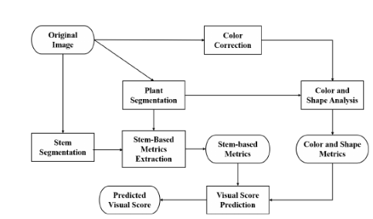

Thesis Criteria

* Is it original enough?
* Is it important/relevant enough?
* Is there enough literature to build off of?
* Will I have access to the data I need?
* Do I have time to collect the data I need?
* Will I have access to required resources?
* Will I be able to analyze the data properly?

For Each Project

* Big picture of the research topic
* How is my topic unique
* Why is it valuable to conduct this research
* How will I undertake this research

THOUGHTS

measure kluster density should be equal to wilting

also color, using color correction attached to drone/camera

Figure out wilting point where need to irrigate or something of that sort

Buy some plants of the same type, different levels of watering, especially underwatering and overwatering, pictures from different sides (with color correction thing) that’s the data. Two pictures a day for the next month. Pictures individually and pictures where they’re all clustered together. Goal is to get better when they’re clustered together

Water stress, nutrient stress, disease and pest stress

When a plant becomes water stressed, it can be expressed by leaf color, morphological state or textures.

nutrient-deficiency are mainly manifested in the leaves, specially the leaf color

Firstly, the segmentation of plant from complicated background in natural light is not resolved successfully for the complicated imaging condition. Secondly, the image processing algorithms are designed for specific plant and it is difficult to extend for different plant in varying conditions. Thirdly, most of the research focused on the detection of one plant stress, but more than one stress are demand in commercial use. Moreover, one or several feature is used for stress detection, but the stress features of different plants vary greatly. How to select the most discriminating feature is still a challenging problem.

the segmentation of plant from complicated, which could be adaptive to the varying of natural light, would still be the hot topic in the future. For detection different feature of the plant’s stress, combing colour, shape and texture features to construct a big feature set and using bio-inspired feature selection to select informative image features, will get more research interesting

Focus on water stress

Non-Machine learning:

Take picture of plant with different levels of water intake over the course of one month (a plant that will completely die within a month) -> 2 plants for testing, 4 plants for getting measurements. These will be used for non machine learning components

* Color analysis

Also use expert knowledge

Testing ML methods to get best water stress detector for specific plant: